Working of I2C communication between two Arduino

Diagram:

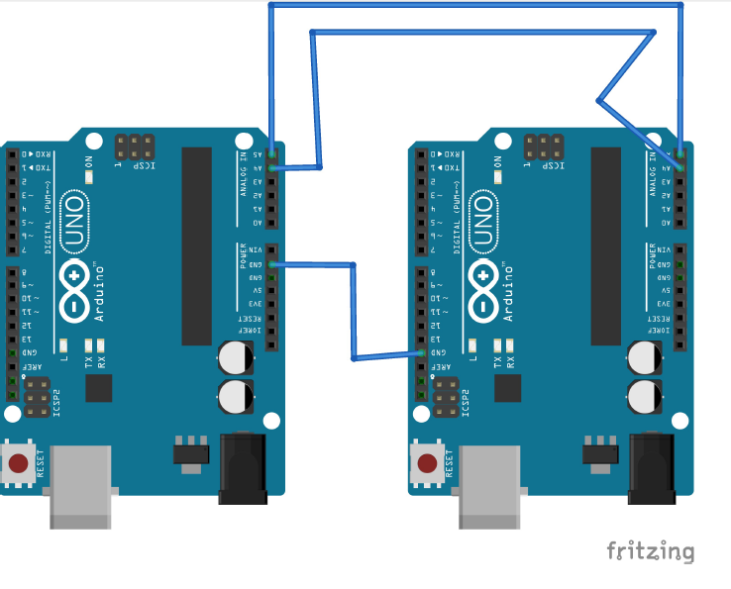

**Working:**

We are required to communicate two Arduino UNO using I2C port. It is important to know Arduino while using I2C requires to be in Master and one to be slave. Multiple Arduino can be interfaced using more slaves by changing its number. The code has been uploaded in github as well.

Important to know Master can send to slave but cannot receive from slave directory as two way communication. It has to receive a request from slave to receive any data.

A wire.h directory is important for i2c communication.

Here only slave is communicating to Master, Slave we will input slave value in code as well for master to know which port is communicating with it